NEA analysis:

Background:

The solution I am creating is for a local food shop in the area of Tottenham that sells chicken and chips. They sell food at cheap prices that is affordable by everyone. The business is self- ran and branches out in most of London in areas of housing, however there are no branches available in central London. In terms of income, the turnover per week the fried chicken shop has is around £3,000, which is the average for a chicken and shop to earn. Local businesses do not tend to have different departments or areas of speciality as they are usually run by 2-3 people, therefore I will be focusing on the business as a whole and intend to improve customer service and turnover. Customer service will be improved as there will be a base where customers are able to access things like food availability, deals, any complaints for the restaurants and services like FAQs that can call be easily accessed by a mobile device or PC, therefore allowing the user and end user to communicate more efficiently and in different ways.

Project scope:

However, until now fried chicken shops have collaborated with services like uber eats and deliveroo for delivery, therefore by designing a delivery website for them the advantage to them will be that they will be able to run deliveries independently which could allow them more interaction with the customers, and be able to implement their own ideas into the way they do delivery, e.g. a 30 minute guarantee offer. This is also possible by phone call, however in this day and age people prefer to use online services and credit card payment for delivery. Furthermore the website is going to function differently depending on the login in system. When the user creates an account on the website they receive loyalty rewards depending on how many times they order or buy food, however in order to make a delivery you can log in as a guest as people usually are in a rush to order food and do not want to go through the process of registering for an account.

There are many programming

Description of the current system:

For now, businesses like this have to rely on apps like just eat and deliveroo and etc. where when customers search for the category their food shop fits into, the customer can select to order from their menu and that's it. The food is then delivered by an employee from JustEat or Deliveroo.

Research of  E-commerce software, Google maps API

E-Commerce Software:

E-commerce software is the engine that is used for making online transactions. This software allows to easily manage inventory, add or remove products, calculate taxes and any other features required to manage a website and fulfil orders.

There are two-types of E- commerce software’s, SaaS and On-Premise.

On-Premise is installed and managed by developers on-site, who facilitate manual updates and do general troubleshooting.

SaaS - The SaaS solutions are more easy to use by people that aren’t tech savvy, compared to on premise the only development requirements are additional design and custom features. All patches and newly-released features are done automatically using one-click integrations. Using SaaS software could reduce the development time by a- lot.

Out of these two I will be using SaaS as it is more efficient and It does not require any on-site developers as my clients do not have any programming or technology experience therefore If a method like on-Premise was used and they have errors with website they would have to pay money for it to be fixed by external developers.

Google Maps API:

An API is a set of functions and procedures that allow the creation of applications which access the features or data of an operating system, application, or other service. I will be integrating the google maps API so I can easily access data from google maps and this will also allow me to integrate location services and delivery tracking.

From the google maps APIs I will be integrating the Distance Matrix API -  which calculate travel times and distance for multiple destinations, roads API to determine the precise route, the Maps Embed API to integrate a map in, and geocoding api to pick up the address of the customer, the position of the shops and position of the delivery driver.

There other maps out there like waze, and bing maps, however I find google maps the best option as they offer the most apis and support and also feature tutorials which makes implementing the API even easier.

Identification of prospective user(s):

Students and teenagers that live around these shops but not in walking distance will be the users using it the most. However the website will be accessible by all as the websites GUI will be simple and accessible by all.

Identification of users needs:

1. The website should be able to offer safe, fast and secure transaction, should be scammer free and easy to use.
2. When food is delivered, should show location of delivery, approx delivery time and how far he/she is from the location of the customers house. This should be possible if successfully connected to the google GUI.
3. Website should display a simple, easy to use GUI and allow users to add items to basket easily and order.
4. Depending on who logs in, webisite should offer different privelages to customer nad employees.

Existing Products:

1. “Domino’s pizza Online Ordering”

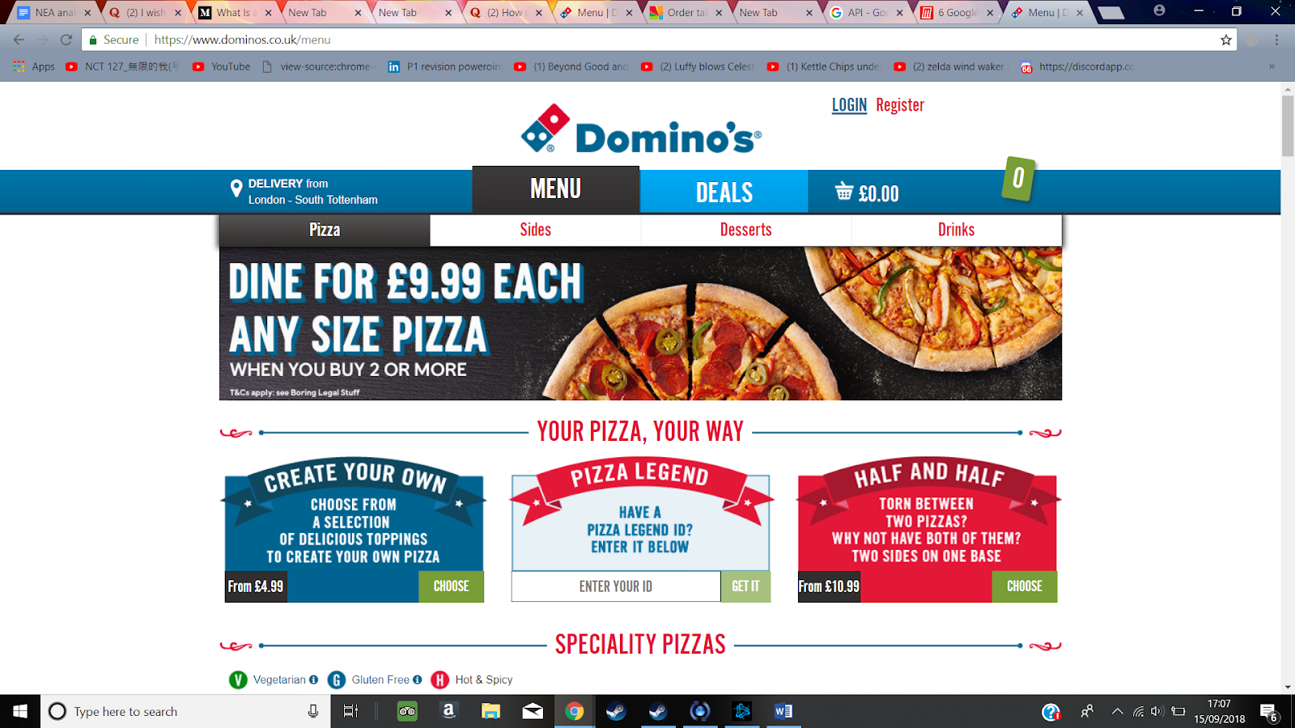

This website offers all the same as the website I am creating offers, for e.g. easy to use, location services and etc. however it does not offer different login privileges, e.g. if an employee logged in he would be shown the same things as a customer.

2): “JustEat”